**Curriculum Vitae**

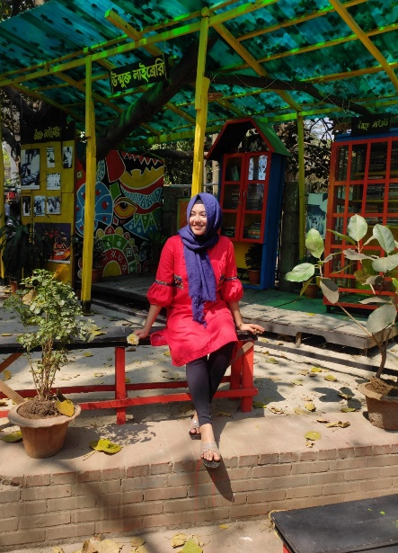

Amatullah Ashika Amin

Mirpur Dhaka,1216

Mobile: +8801*********

E-mail: abc@gmail.com

**Education**

2019 - HSC

BCIC College

Group-Science

2017 - SSC

Monipur High School & College

Group-Science

Present - Bsc Computer Science & Engineering

University of Asia Pacific

**Work Experience**

Volunteering, photograph er

**Organization**

Monipur High School & college Science club

BCIC College Science Club

University of Asia Pacific Cultural fest

**SKILLS**

* Fluent in English
* Communication skills
* English language proficiency
* Graphics design
* Programming skills
* Organizational skills

**Certificates**

1st prize in Monipur High School & College Fest 2016

2rd prize in BCIC College photography club 2019

**Languages**

* English
* Bangla
* Hindi

**Interestes**

* Coding
* Photography
* Cooking
* Travelling
* Astronomy
* Drawing

**Career Object**

To work hard in an organization with full determination and dedication to achieve

organizational as well as personal goals.

**Reference**

Md. Imran Bin Azad

                  Ex. Assistant Professor Computer Science and Engineering

## **Senior Lecturer, BRAC University**

                  University of Asia Pacific

                  Mobile:01915683707

Md. Nahiyan Uddin

                  Lecturer. Department of Computer Science and Engineering,

                  University of Asia Pacific

                  Mobile: 01682057678

Tanjina Helaly

                  Assistant Professor Department of Computer Science and Engineering,

                  University of Asia Pacific

                  Mobile: 01983792229